**Functional Requirements**

**1. User Registration and Authentication:**

- Users should be able to register an account.

**2. Blog Post Creation:**

- Registered users should be able to create new blog posts.

- Each post should have a title and content.

**3. Editing and Deleting Posts:**

- Users should be able to edit and update their posts.

- An option to delete posts.

**4. Viewing Posts:**

- Visitors should be able to view the list of blog posts.

- The ability to click on a post to view its full content.

**5. User Profiles:**

- User profiles displaying their authored posts.

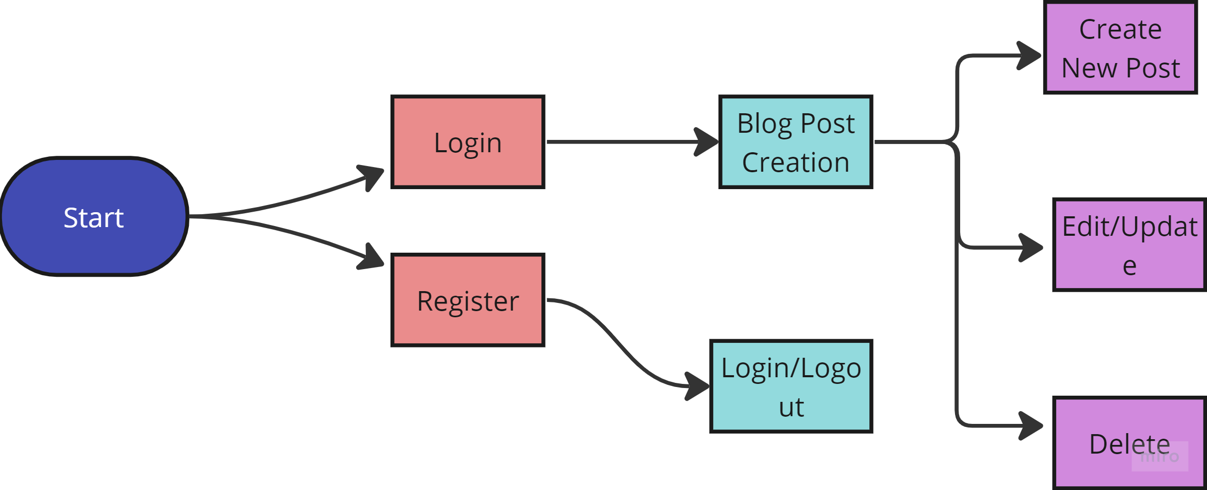

1. To Create Post:

* From Home click Login
* Select new posts to create a new post

2. To Update Post

* Select Update to update/edit posts

3. To Delete Post:

* Select delete